

CAPSTONE PROJECT REPORT
Report 4 – Software Design Document

– Hanoi, August 2019 –

Table of Contents
I. Record of Changes 3
II. Software Design Document 4
1. System Design 4
1.1 System Architecture 4
1.2 Package Diagram 4
2. Database Design 4

I. Record of Changes
Date | A*  M, D | In charge | Change Description
*A - Added M - Modified D - Deleted

II. Software Design Document

1. System Design

1.1 System Architecture
[The content of this section includes the overall diagram which includes the sub-systems, the external systems, and the relationship/connection among them. You need also provide the explanation for each of the diagram components (modules, sub-systems, external systems, etc.)].

1.2 Package Diagram
[Provide the package diagram for each sub-system. The content of this section includes overall package diagram(s) and the explanation for each package (or namespace). Please see the sample and description table format below]
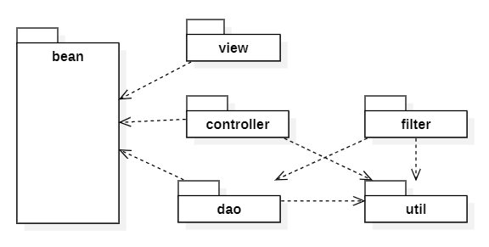
Package Descriptions
No | Package | Description
01 | <Package name> | <Description of the package>
02

2. Database Design
[Provide the files description, database table relationship & table descriptions like example below]
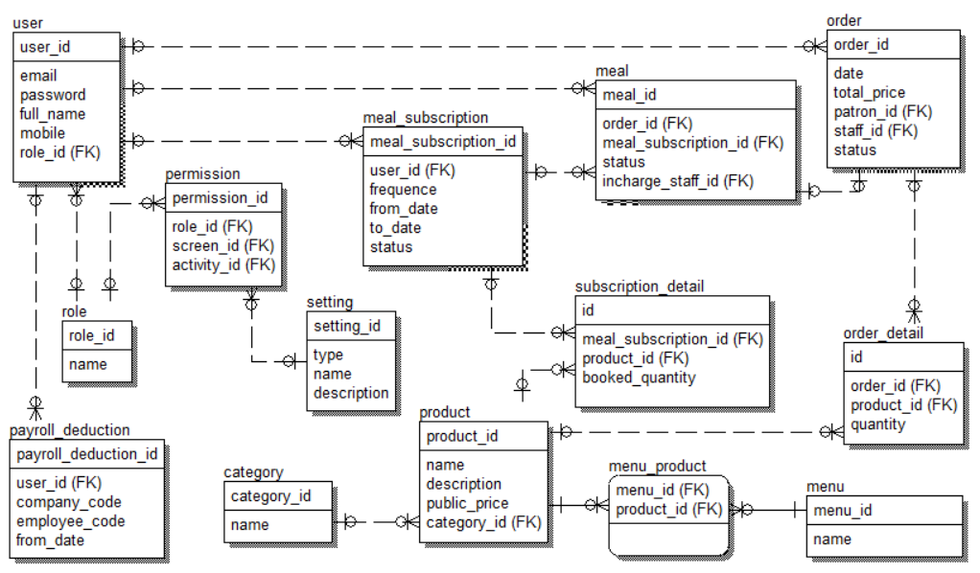
Table Descriptions
No | Table | Description
01 | <Table name> | <Description of the table>  - Primary keys: <<list of primary key fields>>  - Foreign keys: <<list of foreign key fields>>
02 | <Table name2> | …

